JENKINS ASSESSMENT:

1.Simple bash command to print console output.  
"Welcome to Jumisa Technologies"

We have set up an Jenkins page .

And create a job :

Move onto the build step to execute shell,

Run this command

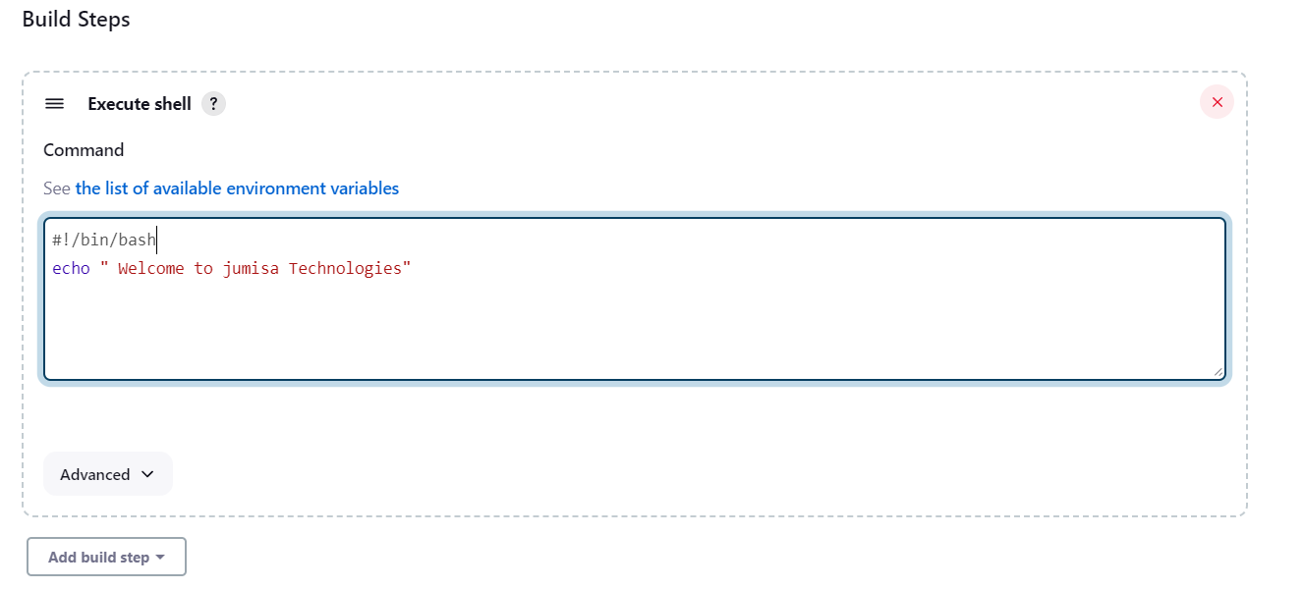

Output:

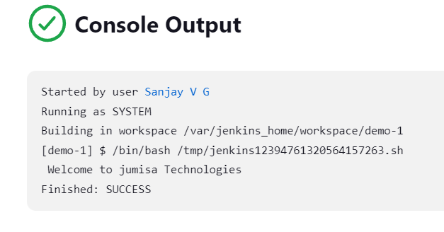

2.Simple bash file to print console output.  
"Welcome to Jumisa Technologies"

We have create a bash file in terminal

Move onto the build step into execute shell,

Add workspace path to the execute shell

Run this command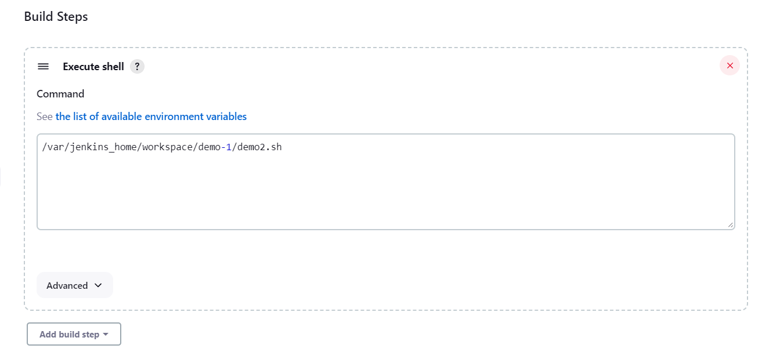

Output:

